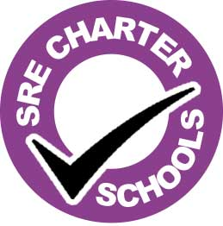
SRE Charter

St. Margaret Clitherow Academy
At our school we believe that the provision of good quality SRE is essential for our pupils. The SRE we provide safeguards our pupils by allowing them to explore what a safe and healthy relationship is, giving them information on appropriate support services, and enabling them to make positive and informed choices about their bodies, sexual health and relationships as they move into adulthood.
Our school believes that:
- effective SRE supports us in safeguarding pupils
- SRE is an entitlement for all young people throughout their school life
- equality and respect lie at the heart of all relationships and that sexist or homophobic language and behaviour are not acceptable and must be challenged
We are committed to providing SRE that:
- is based on the real needs of pupils and is informed by current experiences of young people in today’s society
- is inclusive of a range of relationship choices and families
- is delivered regularly throughout a pupil’s time at the school as part of a comprehensive PSHE programme
- is progressive, enabling pupils to gain knowledge, develop skills and explore attitudes and values in an age-appropriate way from when they start at the school to when they leave
- enables children and young people to make informed, healthy choices and keep safe
- is delivered by trained, confident staff using a variety of active teaching and learning methods
- is complemented by the input of appropriate external providers
- is a partnership with parents/carers
- signposts young people to sources of support both in and out of school
- is delivered in a safe way that enables all pupils to contribute
- is accessible for all regardless of gender, sexuality, sexual orientation, faith, ethnicity, culture or disability

